**Angular MFEs with Modular Federation.**

Angular CLI Version – 15

**ng new mfe-practice-1 --no-create-application**

creates a workspace. The struture generated doesn’t hold any root level application

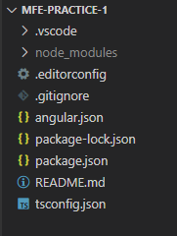

**cd mfe-practice-1**

**ng g application shell --routing --style=css**

**ng g application first-mfe --routing --style=css**

Generates application named shell and first-mfe respectively. These applications are genrated inside projects folder. They can be run individually.

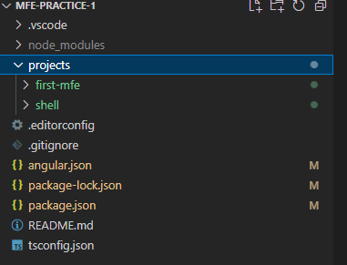

*Edit app-component.html of*

**ng serve shell -o**

**ng serve first-mfe -o**

Runs application. Here the first will take the default port 4200 and later will take 4201